**Impact Central Illinois Annual Report July 2021- June 2022, Third Grant Cycle**

Grants

**39 Nonprofits applied**

3 Focus Areas: Education, Health and Wellbeing, Family and Social Services

3 Finalists for Impact Grant, 3 Finalists for Inspire Grant

2 Winners of Impact Grants of $110,000 each: Dream Center Peoria and Lutheran Social Services of Illinois

New this year: two smaller Inspire Grants

2 Winners of Inspire Grants of $20,000 each: Invictus Woods and Central IL Center for the Blind & Visually Impaired

Total amount of Grants given: $260,000

**Women involved on Grant Review Committees:**

Education: 19

Family & Social Services: 20

Health: 18

Inspire: 17

Finance review committee: 11

Total # of women active on committees: 85

Membership

**Growth**

Grant Cycle 1 - 130 founding members

Grant Cycle 2- 180 members

Grant Cycle 3- 235 Members

**Sponsorships**

For third Grant Cycle ending July 2022, of the 235 total members:

25 were Sponsored Members

14 of the sponsored members were sponsored by another Member

             11 of the sponsored members were sponsored by Impact Central Illinois **(**8 COVID CAT Match 2nd year sponsorships included)

**Retention**

85% Retention rate from 2nd to 3rd Grant Cycle

73% Retention rate from 1st to 2nd Grant Cycle

We continue to find ways to engage existing members which we feel impacts retention. New members are recruited by referral from existing members, often by inviting them to gatherings in homes hosted by members. For the third Grant Cycle there were 8 of these new member recruitment gatherings.

Beyond Giving

To fulfill our mission of educating members about needs in our community and how to be better philanthropists, we initiated Beyond Giving in the Spring of 2022. Since effective philanthropy means understanding the needs of our community, educational events included a poverty simulation and book discussion group in April 2022. The Beyond Giving Committee planned educational events for members and community outreach projects to support past grant award winners which we call Community Partners.

For the initial year after receiving a grant, Impact encourages members to learn more about our Community Partners. The Beyond Giving Committee selects at least one volunteer activity with each Community Partner and encourages our members to volunteer at it. The committee also posts regular project updates on social media so members can see progress as our Community Partners make use of the grant we gave.

Marketing

**Facebook**

July 2020 - 584 followers

July 2021 - 784 followers

July 2022- 982 followers

I**nstagram**

July 2020 - 326 followers

July 2021 - 540 follows

July 2022- 664 followers

The Marketing committee initiated a major project to update the website with a “Members-Only” access area. This new site will provide interactive functionality and web-based features such as message boards, e-invites, event registration, and calendars. It also will interface with our Quickbooks software allowing easy membership renewal and invoicing. Launch is scheduled for November 1, 2022.

Updated logo using donated talent of a local female artist, Marisa Weyeneth (Instagram: @lil.and.e).

Events

**Impact and Inspire**

* Held every year on the last Thursday in January
* Goal is social interaction and inspiration for the grant review season
* Includes a speaker or speakers
* Speakers in 2022: Michelle Sullivan and Chris Reynolds. Michelle is a former President of the Caterpillar Foundation and a globally recognized leader and advisor in social impact, as well as TED speaker and author. Chris is the Bradley University VP of Intercollegiate Athletics. Under his leadership the Braves enjoyed their most successful five-year run in department history across all sports programs.
* Total expenditures: $500

**Annual Meeting**

* Held every year on the first Tuesday in June.
* Held June 7, 2022 at Trailside event center
* Grant season finale and celebration where grant finalists present their program and members vote on which non-profit(s) receive the grant(s).
* Members unable to attend may review grant finalists’ information sent out in advance to all members, and mail in their ballot prior to the annual meeting.
* Total expenditures: $3,443

**Town Hall**

* Held every year on the third Tuesday in September
* Business meeting for members where we update them on the business of Impact CI and provide an Annual Report.
* Community Partners inform members of the needs in our communities and how grant giving has impacted those needs
* Total expenditures: $719

Finance

**July 2022, Third Grant Cycle, Total Grants awarded:** $260,000

Breakdown of funds:

Each member gives $1,100 per grant year. **The organization raised $260,000 in grant funds; $25,000 from the Gilmore Foundation and the rest from membership and matches**. These funds are set aside and will be distributed to our grantees over the next 24 months.

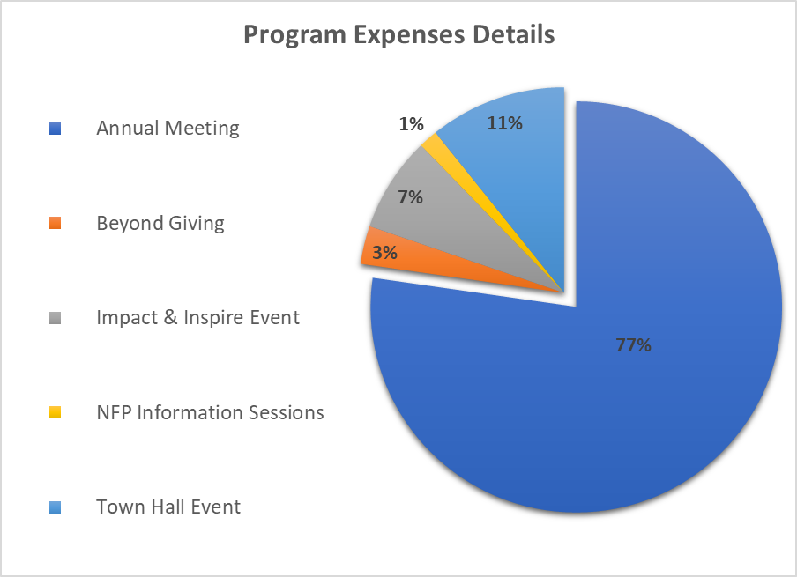

For questions about finances please contact: Vivian Standiford, Treasurer

[email:](mailto:weor0716@msn.com) [vstandifird@fsmail.bradley.edu](mailto:vstandifird@fsmail.bradley.edu)

or cell phone: 317-619-0476